**Photochemistry and Photophysics**

**2022/9/6**

1. 期中考试，期末考试

2. 少数化学，光催化有机合成，主讲光物理

3. 10%(提问) 30%(期中) 60%(期末)

4. ground state – excited state

5. refraction (折射) transmission (透射) reflection (反射) incidence (入射)

6. normal (法线)

7. 臭氧可吸收高能紫外线，小于300 nm。

8. 400(B) -500(G)-700(R) nm visible range

9. HOMO-LUMO (Highest occupied molecule orbitals – Lowest occupied molecule orbitals)

10. 名词解释：

Photochemistry and photophysics are process experienced by molecule that accept the light irradiation. Namely, photochemistry is chemistry process while photophysics is physical process.

11. electronically-excited state

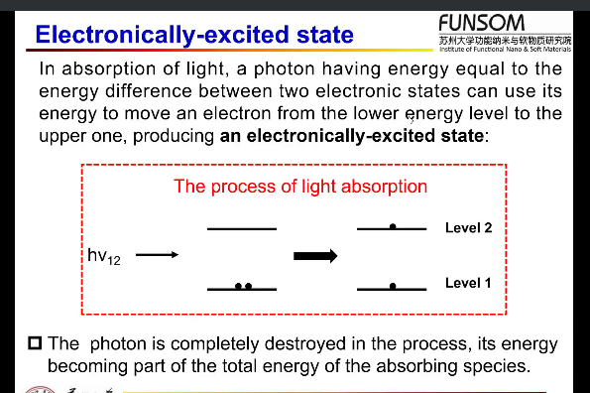

O（氧） 是成对出现，不是单个电子激发

12.名词解释

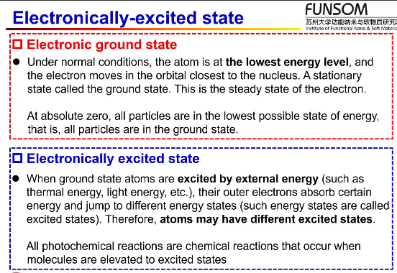

Electronic ground state: The steady state of the electron, which allows the atom to be at the lowest energy level and the electron moves in the orbital closest to the nucleus.

Electronically excited state: The state of electron that excited by external energy along with the energy absorption and the movements of electron from ground state to different higher energy orbitals.

13. Laws:

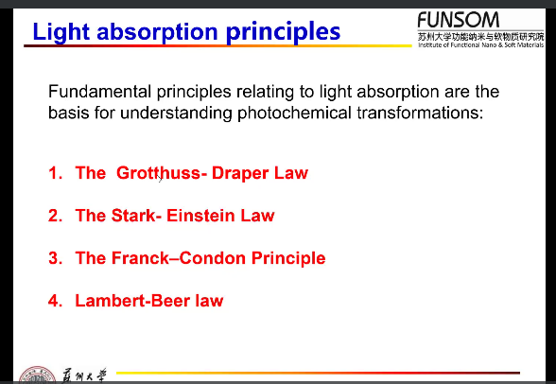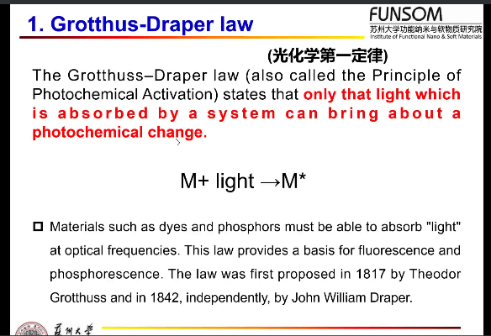

G-D: only the light which is absorbed by a system can bing about a photochemistry change.

II

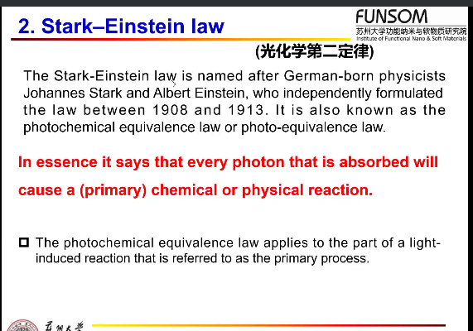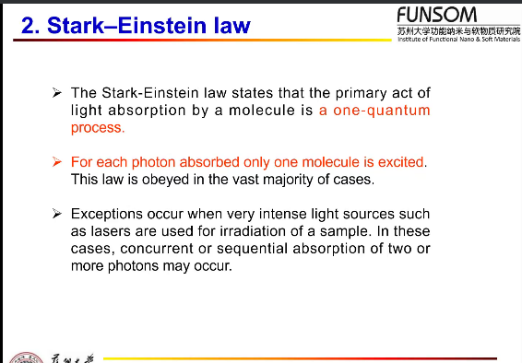

单量子过程 except the laser.

III. Nuclear no change

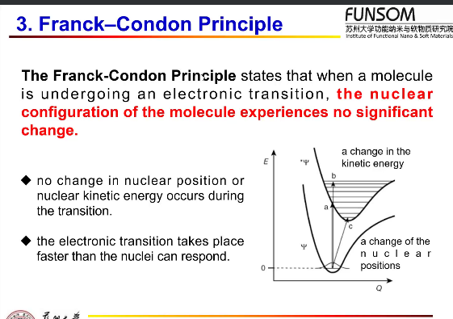

IV. 分光光度原理：concentration and thickness determine the absorbance.

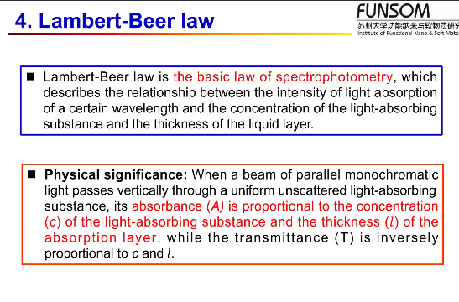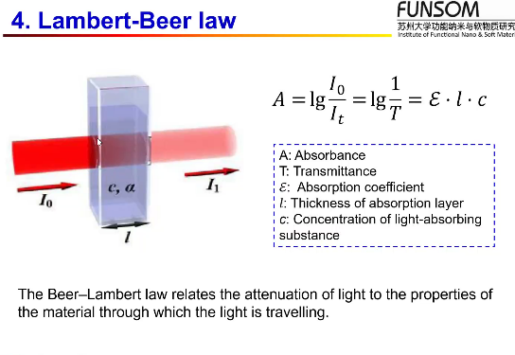

14. selection rules for light absorption.

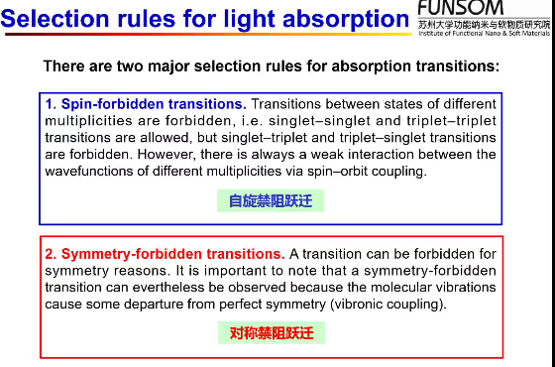 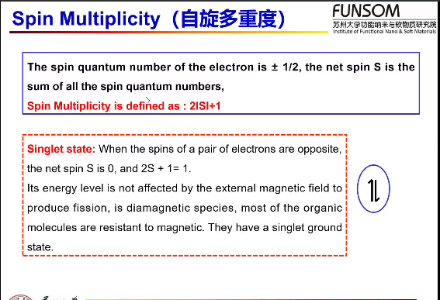

Spin-forbidden transitions: transitions between states of different multiplicities are forbidden.

symmetry-forbidden transitions: a transition can be forbidden for symmetry reasons(departure 背离 from perfect symmetry such as vibronic coupling 电子振动耦合).

单线态（singlet state）：所有配对电子的自旋(1/2)呈反平行的状态。净自旋S=1/2-1/2=0 三线态 (triplet state)：所有配对电子的自旋(1/2)呈同向平行的状态。Double state: 单电子净自旋S=1/2+1/2=1, 磁量子数M=2S+1. （自旋多重度）。

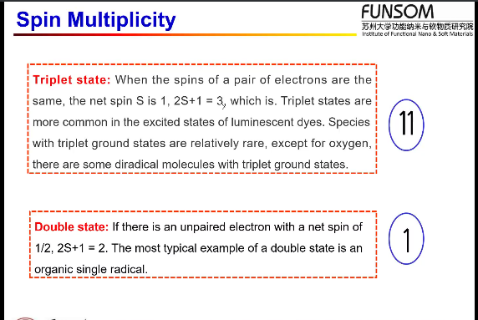

O: triplet state. The singlet state of [O] is harmful to the cells